Logo



**St Mark’s Cathedral, Bangalore**

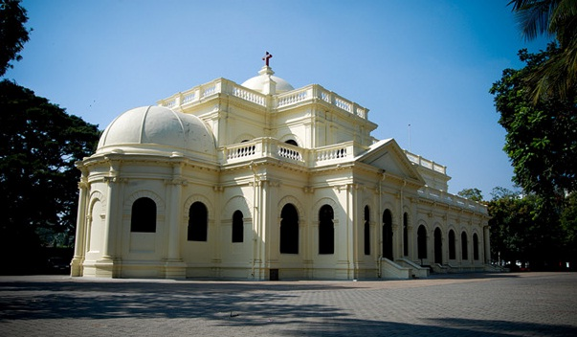

**Dr. Joyce Siromani**

Founder and First Secretary of MPA

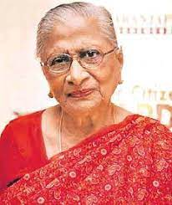

**Foundation stone laying by G V K Rao (Chief Secretary)**

**(in the presence of Benjamin Isaac, R M Varma, S S Jayaram, besides others)**

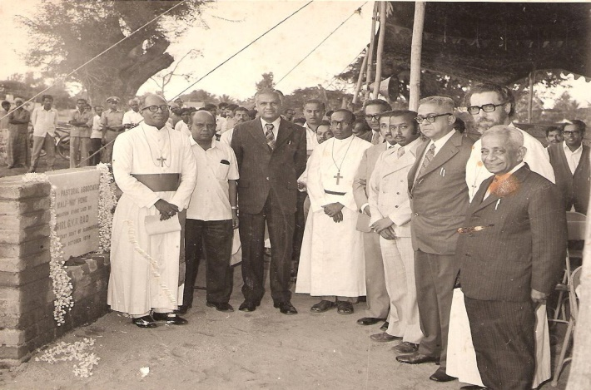

**First building completed, the Administrative Block**

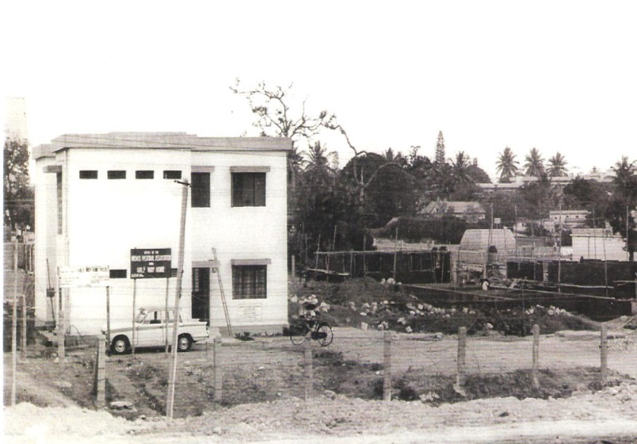

**The Half Way Home**

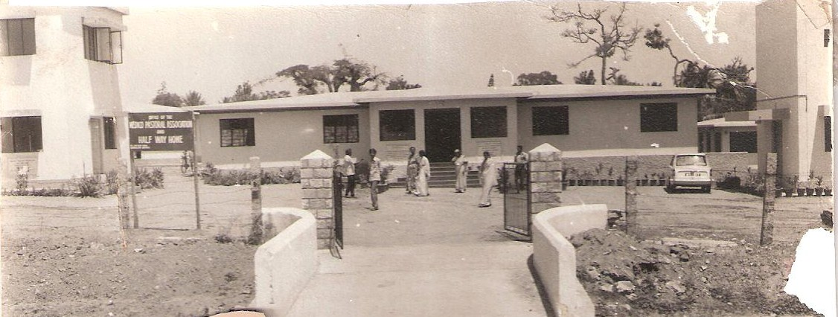

Half- Way Home (present)

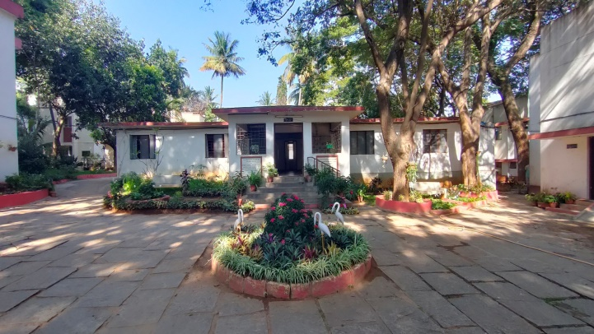

Navajeevan Hostel

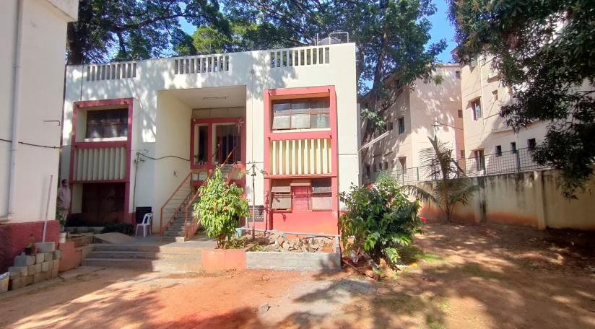

Ladies Cottage

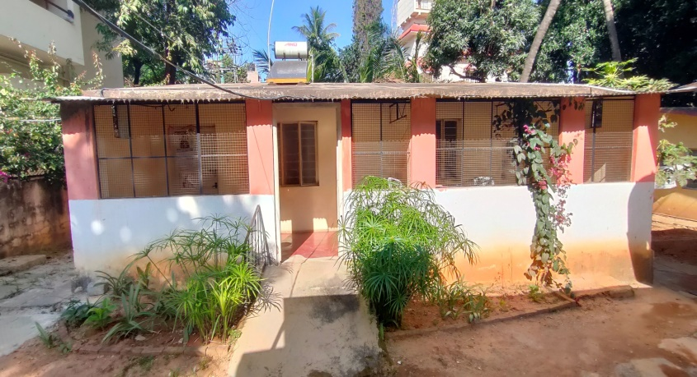

Auditorium

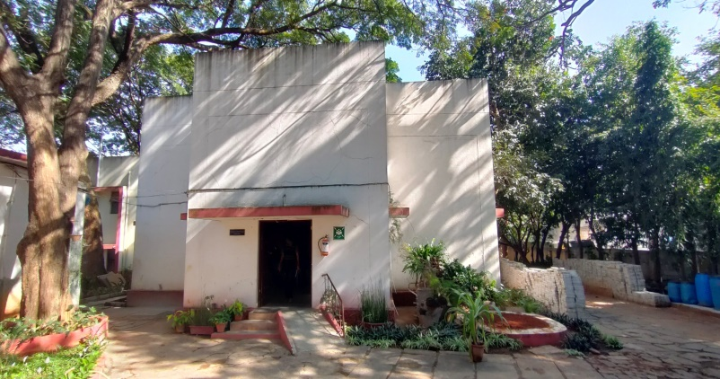

Staff Quarters

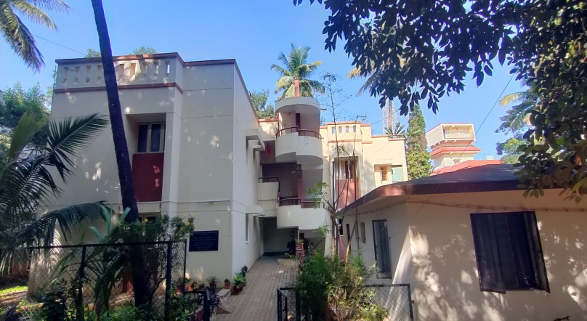

**Staff Photos**

**Administrative**

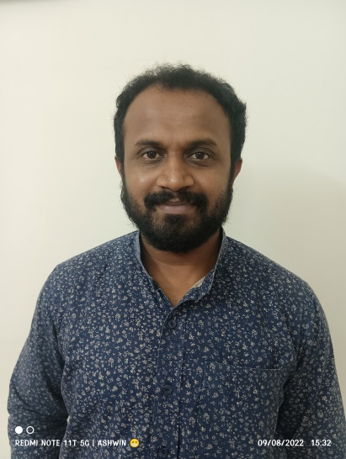

**Bhaskar N G**

Administrator

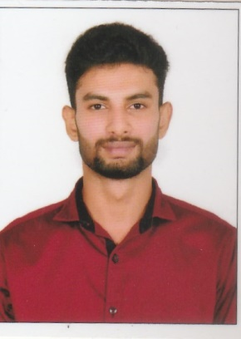

Sajan K.S

Accountant

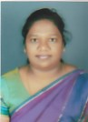

**Anita Charles**

Receptionist

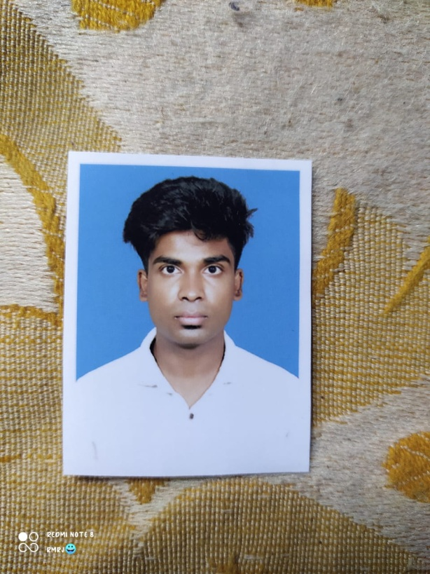

Rakesh R

Office Assistant

**Clinical Staff**

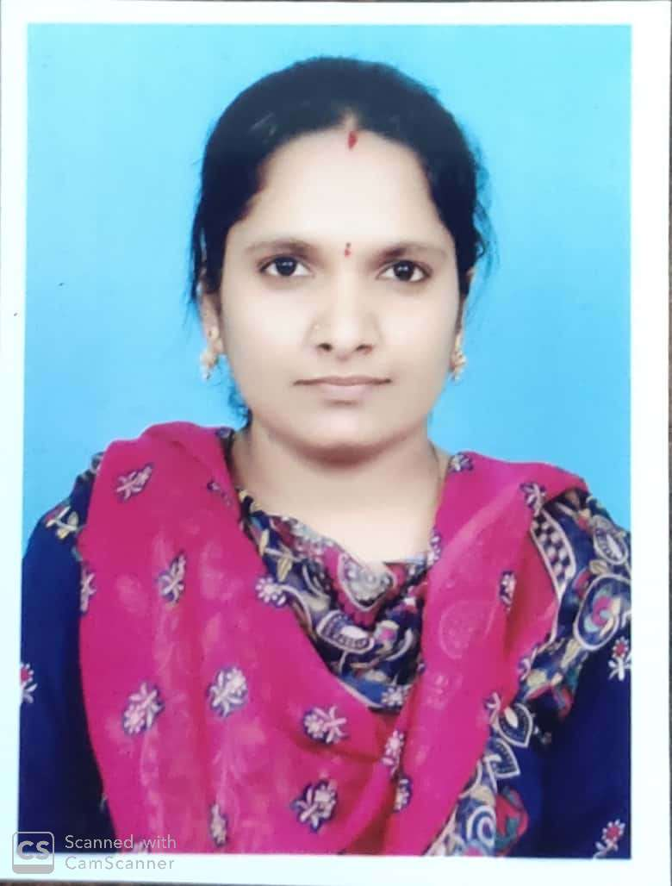

Agalya. V

Joint senior Counsellor

Aneesh Thomas

Joint senior Counsellor

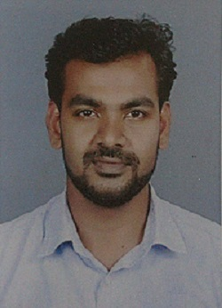

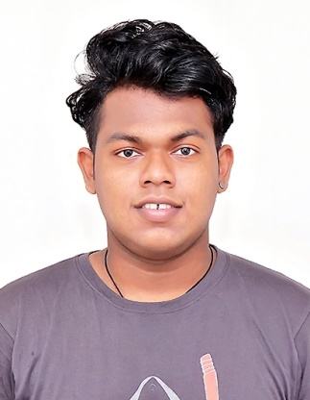

Ashwin O B

Counsellor

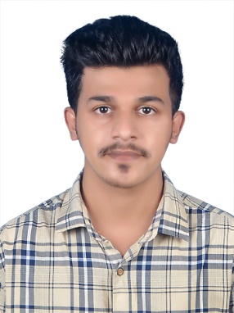

Syed Zaeem Jifri Counsellor

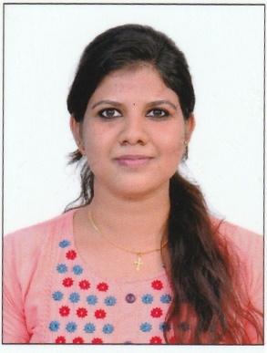

Reshma J

Counsellor

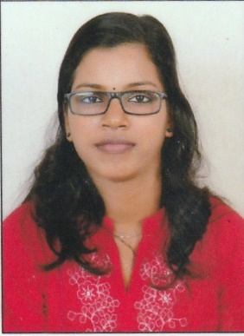

Amrutha B

Counsellor

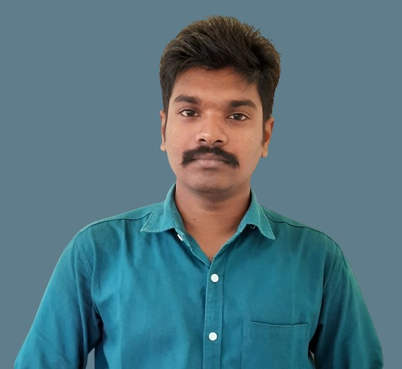

Denil Varghese

Residential Counsellor

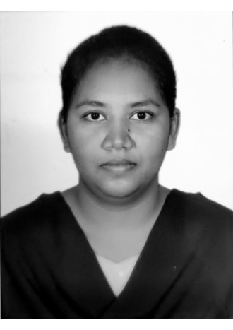

P. Mercy Jyothsna

Residential Nurse

**Facility Staff**

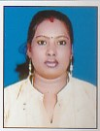

**Mary Stella**

Ass .Rehab Facility Manager

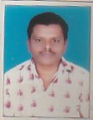

**Ravi C Mark**

Cook

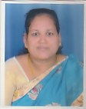

**Ganga S**

**Cook**

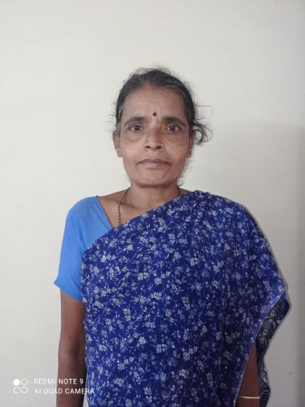

**Geetha R**

Helper

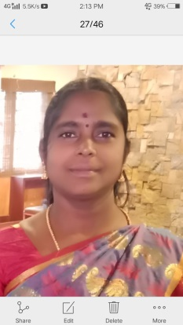

**Muniyamma**

Helper

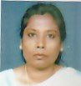

**Amudha**

Helper

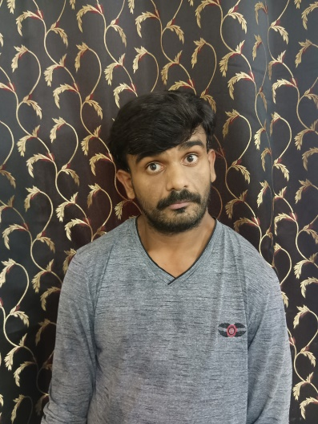

Chethan J N

Gardner

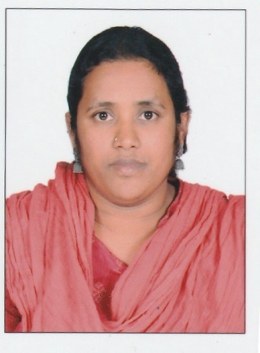

Maria B

Helper

Roja Lilly Mary

Helper

**Awards**

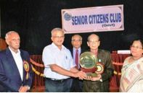

In 2012, MPA received the Padmabushan Doctor M.C. Modi Service Award for the second time from the Senior Citizens Club (Government), Bangalore.

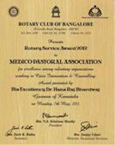

In 2012, MPA received Rotary Service Award for Excellence among NGO’s (Voluntary Organizations) Working in Counselling and Crisis Intervention

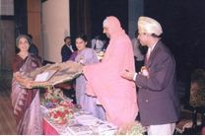

In 2000, MPA received the Distinguished Service Award from the Indian Psychiatric Society, Karnataka Branch.

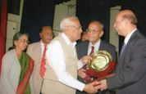

In 2007, MPA received the Padmabushan Doctor M.C. Modi Service Award from the Senior Citizens Club (Government), Bangalore.

**PROGRAM**

**LECTURE SERIES**

**THE LECTURE SERIES IS BASED ON THE 5Oth YEAR OF SERVICE OF MENTAL YEAR FULL OF LECTURE**

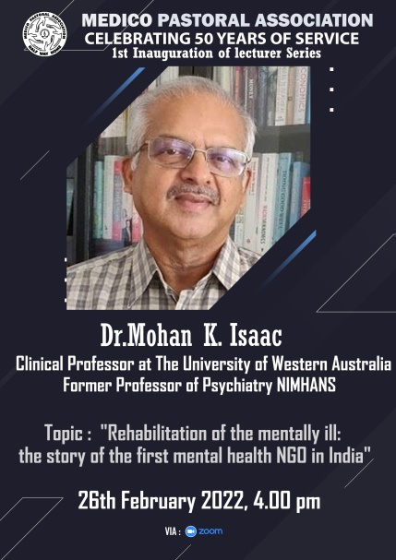

Lecture 1:

Dr. Mohan Isaac he inaugurates the series with is lecture the topic of the lecture is **“rehabilitation of mental ill: the story of the first mental health NGO in India”.**

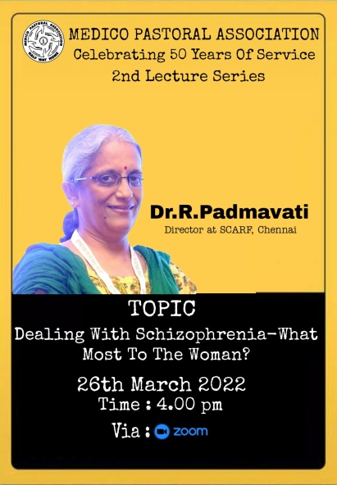

Lecture 2:

Dr.R.Padmavati is a lecturer for the second series the topic is **Dealing with Schizophrenia –What most to the Woman?**

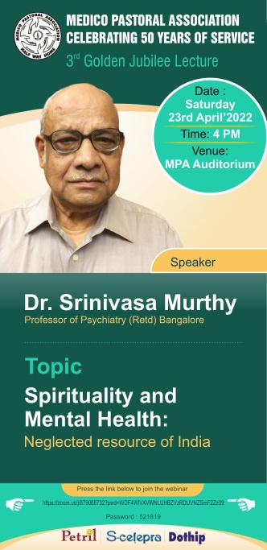

**Lecture 3:**

**Dr.Srinivasa Murthy is a lecturer for the 3rd series the topic is Spirituality and Mental Health: Neglected resource of India.**

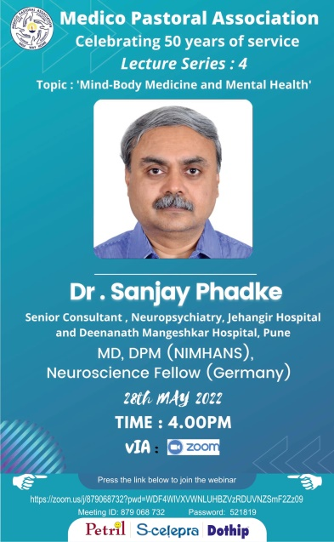

Lecture 4:

Dr.Sanjay Phadke is a lecturer for the 4th series the topic **is “Mind-Body Medicine and Mental Health”**

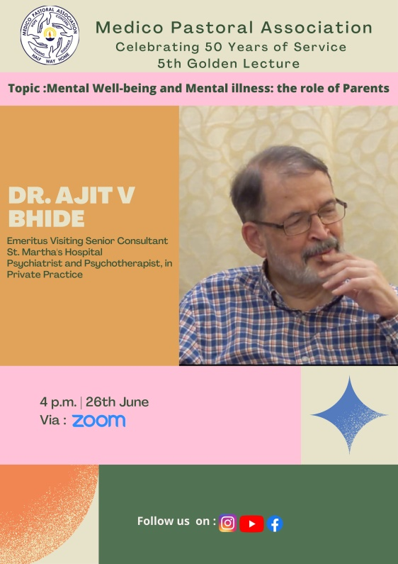

Lecture 5:

Dr.Ajith V Bhide is a lecturer for the 5th series the topic **is Mental Well-being and Mental illness: the role of parents**

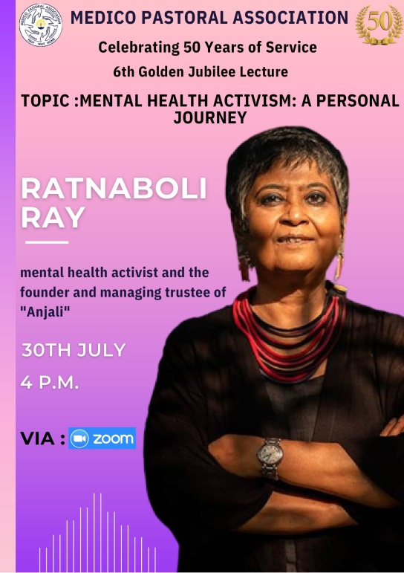

**Lecture 6:**

Ratnaboli Ray is a lecturer for the 6th series the topic is **Mental Health Activism: A Personal Journey**

**Christmas Celebration**

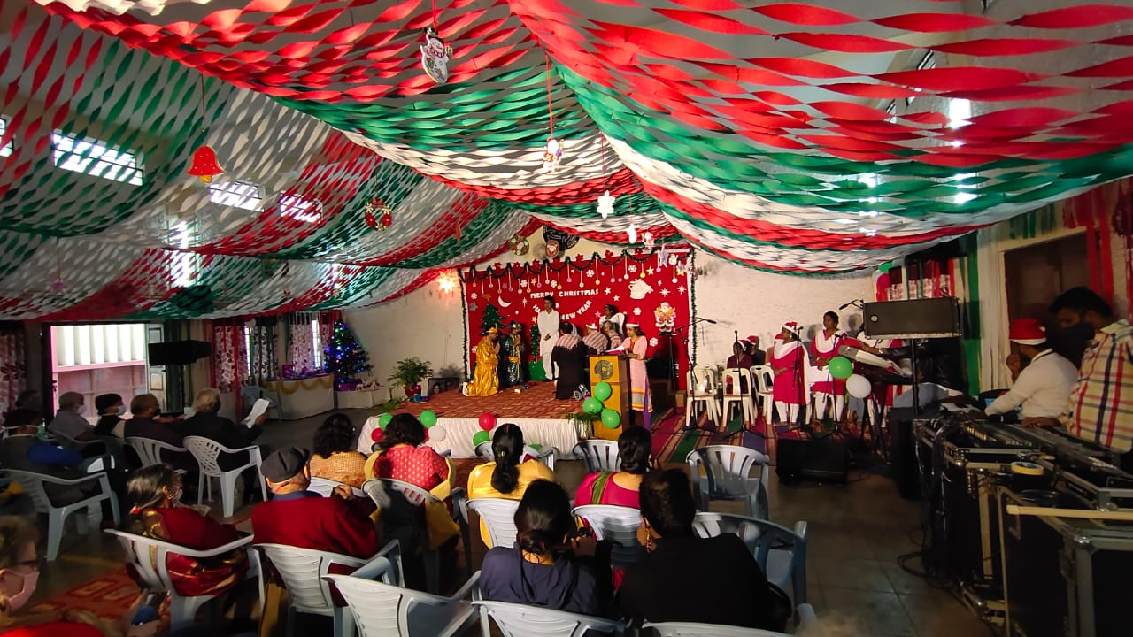

**Observing WMHD- Inter Psycho-Social Rehabilitation Competition**

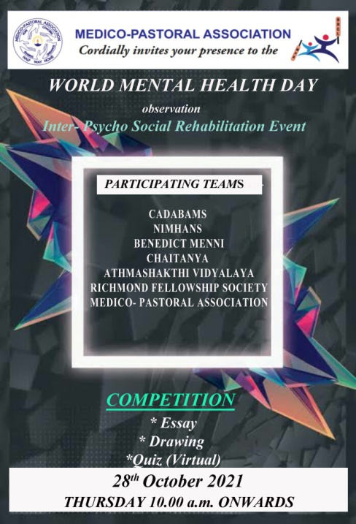

On the occasion of observing World Mental Health Day, MPA has a history of conducting BRCL (Bangalore Rehabilitation Cricket League) tournament with other psycho-social rehabilitation but past two years, due to COVID-19 Pandemic the tournament has been postponed indefinitely. To continue the spirit of enthusiasm and motivation of the residents of various organizations this year we organized (virtual event) with few competitions for the residents of different Psycho- Social Rehabilitation centers.

On Thursday, 28th October, 2021 Inter –Psycho Social Rehabilitation Competition was organized by the Medico-Pastoral Association among Cadabams, NIMHANS, Athma Shakthi Vidyalaya, Richmond Fellowship Society, Benedict Menni Rehab Centre Trivandrum Kerala and Chaitanya Institute of Mental Health Pune.

**Women’s Day Celebration**

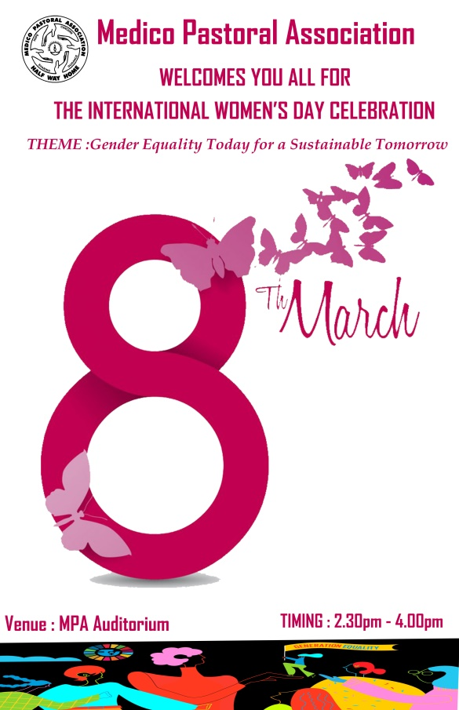

**Foundation day 2022**

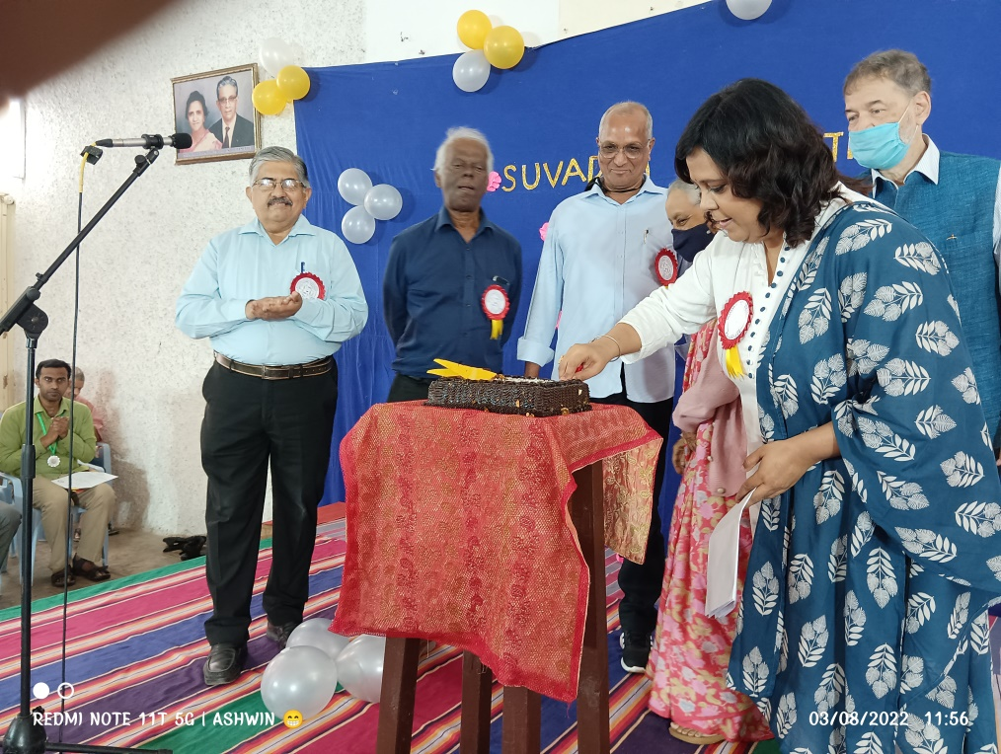

The Foundation Day of MPA was observed on 3 rd August 2022 as part of Golden JubileeYear celebration. The day was celebrated by acknowledging and thanking the people whohelp MPA for its daily functioning.

**Dr.Joyce Siromoni Birthday**

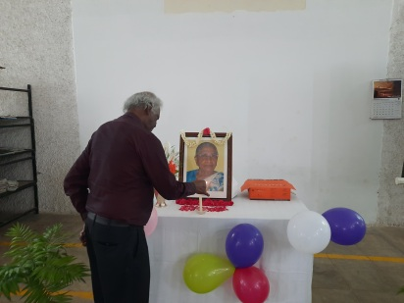

On 22nd October 2021, we remembered and celebrated the birthday of Dr. Joyce Siromoni founder and the first Secretary of Medico Pastoral Association in MPA auditorium. The programme started with a prayer song. Gathering was welcomed &amp; introduction was given by Mr. Samuel Mohan, Secretary. Cake cutting by our senior resident Ms. Yangke Laden followed. Wishes shared by all the members and staff. Few games were conducted for the residents, and the programme ended with a song by residents.